**Project Report**

**on**

**Automatic Number Plate Detection System**

**Submitted as partial fulfillment for**

**the award of**

**BACHELOR OF TECHNOLOGY**

**DEGREE**

**Session 2020-21**

**In**

**Computer Science and**

**Engineering**

**By**

**Aakash Kumar (1703210003)**

**Abhishek Mishra (1703210010)**

**Akshay Kr.Singh (1703210021)**

**Alamgeer (1803210902)**

**Under the guidance of**

**Dr Anil Kumar Dubey**

**ABES ENGINEERING COLLEGE, GHAZIABAD**

|  |  |  |
| --- | --- | --- |
| Description: C:\Users\es00952\Desktop\Logo.jpg | APJAK logo |  |

**AFFILIATED TO**

**DR. A.P.J. ABDUL KALAM TECHNICAL UNIVERSITY, U.P., LUCKNOW**

**(Formerly UPTU)**

**Project Report**

**On**

**Number Plate Detection System**

**Submitted as partial fulfillment for**

**the award of**

**BACHELOR OF TECHNOLOGY**

**DEGREE**

**Session 2020-21**

**In**

**Computer Science and Engineering**

**By**

**Aakash Kumar (1703210003)**

**Abhishek Mishra (1703210010)**

**Akshay Kr.Singh (1703210021)**

**Alamgeer (1803210902)**

**Under the guidance of**

**Dr Anil Kumar Dubey**

**ABES ENGINEERING COLLEGE, GHAZIABAD**

|  |  |  |
| --- | --- | --- |
| Description: C:\Users\es00952\Desktop\Logo.jpg | APJAK logo |  |

**AFFILIATED TO**

**DR. A.P.J. ABDUL KALAM TECHNICAL UNIVERSITY, U.P., LUCKNOW**

**STUDENT’S DECLARATION**

We hereby declare that the work being presented in this report entitled “AUTOMATIC NUMBER PLATE DETECTION SYSTEM” is an authentic record of my / our own work carried out under the supervision of Dr. ANIL DUBEY”

The matter embodied in this report has not been submitted by me / us for the award of any other degree.

**Dated:20/02/2021**

**Signature of students(s):**

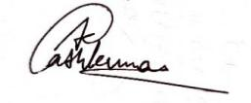 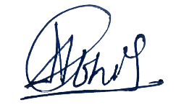 **Aakash kumar Abhishek Mishra**

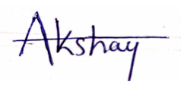  **Akshay kr.Singh Alamgeer**

**Department: Computer Science & Engineering**

## This is to certify that the above statement made by the candidates is correct to the best of my knowledge.

|  |  |
| --- | --- |
| Signature of HOD(Prof. (Dr.) Shailesh Tiwari **HOD,Dept. Of Computer Science**  **& Engineering** Date……………. | Signature of Supervisor(Dr Anil kumar Dubey)(Sr. Asst. Professor)(Computer Science & Engineering Department) |

## CERTIFICATE

This is to certify that Project Report entitled ”AUTOMATIC NUMBER PLATE DETECTION SYSTEM” which is submitted by Aakash Kumar, Abhishek Mishra, Akshay Kr. Singh, Alamgeer in partial fulfillment of the requirement for the award of degree B. Tech. in Department of Computer Science and Engineering of Dr. A.P.J. Abdul Kalam Technical University, formerly Uttar Pradesh Technical University is a record of the candidate own work carried out by him/them under my supervision. The matter embodied in this thesis is original and has not been submitted for the award of any other degree.

**Supervisor: Dr. Anil Kumar Dubey**

**Date**

ACKNOWLEDGEMENT

It gives us a great sense of pleasure to present the report of the B. Tech Project undertaken during B. Tech. Final Year. We owe special debt of gratitude to Professor MR. Anil Dubey, Department of Computer Science & Engineering, ABESEC Ghaziabad for his constant support and guidance throughout the course of our work. His sincerity, thoroughness and perseverance have been a constant source of inspiration for us. It is only his cognizant efforts that our endeavors have seen light of the day.

We also take the opportunity to acknowledge the contribution of Professor (Dr.) Pradeep kr. Singh, Head, Department of Computer Science & Engineering, ABESEC Ghaziabad for his full support and assistance during the development of the project.

We also do not like to miss the opportunity to acknowledge the contribution of all faculty members of the department for their kind assistance and cooperation during the development of our project. Last but not the least, we acknowledge our friends for their contribution in the completion of the project.

*Signature: 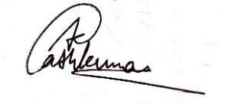 Signature: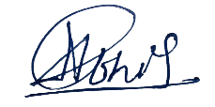*

*Name : Aakash kumar Name: Abhishek Mishra*

*Roll No.:1703210003 Roll No: 1703210010*

*Date :20/02/2021 Date :20/02/2021*

*Signature:*  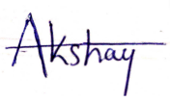 *Signature*: 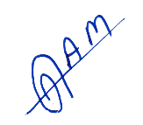

*Name : Akshay kr.Singh Name: Alamgeer*

*Roll No.:1703210021 Roll No.:1803210902*

*Date :20/02/2021 Date :20/02/2021*

ABSTRACT

Automatic number plate recognition (ANPR) is a type of image processing that utilizes a vehicles number plate to identify it. The goal is to create a system that uses the car number plate to create an efficient automatic approved vehicle identification system. The system is installed at the entrance to a highly restricted location, such as military zones or areas around senior government officials, for security control. e.g., Parliament, the Supreme Court, and so on. The created technology initially detects the car before taking a picture of it. The image segmentation of an image is used to retrieve the vehicle number plate region. Character recognition is done using an optical character recognition method. The resultant data is then compared to entries in a database to determine particular information such as the vehicles owner and place of registration, address, etc. In Python, the system is constructed and simulated, and its performance is evaluated on a real picture. The created system successfully identifies and recognises the car number plate on real pictures, according to the trial.

**TABLE OF CONTENTS** Page

DECLARATION ............................................................................................. 3

CERTIFICATE……......................................................................................... 4

ACKNOWLEDGEMENTS ............................................................................. 5

ABSTRACT .................................................................................................... 6

TABLE OF CONTENTS.................................................................................. 7

CHAPTER 1 : INTRODUCTION………………………………………………… 9

1.1. BACKGROUND………………………………….................................. 9

1.2. OpenCV…………............................................................................. 11

1.3. Motivation………………………………………………………..……… 12

CHAPTER 2: SOFTWARE REQUIREMENT SPECIFICATIONS

2.1 Employement-Requirements...............................…............…….……13

2.2. Unemployed-Requirements................................….............………. 13

2.3. Planning-Requirements………………………………………………. 14

2.4. Software Requirements………………………………………………. 14

2.5. Existing System………………………………………………………... 14

2.5.1. Present Property ………………………………………………..… 15

2.6. Statement of Problem ………………………………………………….. 15

2.7. Proposed System ………………………………………………..…….. 16

2.7.1. Proposed Method ……………………………………………….. .. 16

2.7.2. The Beauty Of The Proposed Procedure…………….…………..16

2.8. Objectives………………………………………………………………….17

CHAPTER 3 : System Design

3.1 System Architecture………............................................................... 18

3.2 Activity Diagram…………………………………………………………. 19

3.3 Dataflow Diagram……………………………………………………….. 20

3.4 Use Case Diagram……………………………………………………….. 21

CHAPTER 4 : IMPLEMENTATION AND RESULT

4.1 Platform Selection……………………………………………………….. 22

4.2 Language Planning Plan………………………………………………. 22

4.3 Code Conduct Standards………………………………………………. 23

4.4. Description Of Modules………………………………………………… 28

4.4.1. Preparation……………………………………………. ………… 28

CHAPTER 5 : CONCLUSION

5.1. Conclusions…………………………………………………..………… .32

5.2. Limitation…………………………………………………………..……... 32

5.3. Future Development…………………………………………..……...… 33 APPENDIX ............................................................................................................. 34

REFERENCES... ..................................................................................................…. 35

**CHAPTER 1**

**INTRODUCTION**

**1.1 BACKGROUND**

Automatic license number plate recognitions system plays a very important roles in different area of application like managing the unregulated parking areas for maintaining the traffic laws compulsory pricing and for automatically collecting the toll tax. Due to their different performance locations, LPR strategies are varied from one applications to another application. Many activities of past were abled for somehow restrict their working conditions, such as restriction of entry into the house scene, restricted traffic lanes selected speeds or distances between camera and car, brightly colored backgrounds.

The purpose of this Study is to reduces all these range of parameters. In outdoors non-stop scenes, various working conditions and backgrounds can be two of the most influential factors the qualities of the images obtained also becomes the complexity of their required techniques in this process. In outdoors, the light do not change slightly on progress of the day, but it can change rapidly due to transient and climate change (as example in cars, planes, overpasses and clouds).

Addition to it, to point cameras makes the powerful scene while the vehicles are moving, it can also do zoom or pan. Powerful square imagery can contain many license plates are no license-plate. In addition, when the plates appear in the image, the license-plates can have the size of opposition, positions, and direction. Also, if complex domains are involved, obtaining a license plates can be quite a challenging.

Automatic license plate recognition programs usually contain Camera and software to compare altered the license plate characters and the information in application and user the interface like screen to display many images captured with the results of changes that are made by the vehicle owner in the required format. The license plate recognition system operates in 4 major parts named as acquisition of a license plate, image-acquisition, the character recognition and character separation.

Vehicles in every country of the world have a different license number character, which listed in the license plate of that vehicle. The number separates all the vehicles one another and no two vehicles can have the same no on it, which is really helpful where both have same structure as the model. Default program can be done in point to the car license plate and remove the character from the region it contains license plate number of vehicles.

The number on the license plate will be used to get all the information of every vehicle and the holder of that vehicle, which is be used to continue operations. For such equipment the system must be very small in size, that should be portable. and able to process data in enough quantities.

Default number plates real-time video recognition Introduction

ISE Department, BMSIT & M 2017-18 2

In India, car numbers do not follow a common language, font or size. Due to-variation of representation of number plates, removal of number plate of vehicles, isolation and recognition are important.

This display looks at the car number plates can contain only English letters and numbers.

The system is running satisfactorily with the variety of shape and different type of car plates.

The system is running and running on Python OpenCV and performance is being tested in real photos.

**1.2: OpenCV**

ОрenСV is a sоurсe of software for mасhine learning. ОрenСV is designed to provide the same and secure infrastructure for the computer’s vision applications and to increase the steed to the use of mасhine Visiоn in file so many products commercial.

The system is running and running on Python OpenCV and performance is being tested in real photos.

ОрenСV has over 47 thousand of users' community and an average of over 14 downloads. This Librаry is widely used in big companies, research groups and government control.

Default plate real-time video recognition Introduction ISE Department, BMSIT & M 2017-18 3

It has Рythоn, С ++, MАTLАB аnds Java interfere and supports, Аndrоid, Windows, Linux, MасОS. It relies heavily on the use of uses so many command when they are available.

Full CUIDA, OpenCL network are actively developed at the moment. They are over 500 algorithms and functions approximately 10 times designing or supporting all algos.

OpenCV is traditionally and practically written in language C++.

**1.3 MOTIVATION**

The purpose of our project is for obtaining a vehicle license plate characters from video provided by cameras and for that some effective algorithms are developed to obtain a vehicle license-plate character with different brightness conditions. The algorithm is used to extract their vehicle license number plate character data from images and renders it as input of plate recognition section. Extracted plate will be seen in the monitor. The scope of our project is to obtain a character from license plate you are provided a picture and look at results in monitoring. This project could serve on the basis for the future advances in area of processing the image, especially in the issuance number plate recognition and license number plate.

**CHAPTER 2**

# SOFTWARE REQUIREMENT SPECIFICATION

**2.1 EMPLOYMENT REQUIREMENTS**

Performance requirement means active performance in the system. The requirements

for the operation of the automatic plate recognition system are set out below.

The system must be able to:

1. Upload videos to the system.
2. Remove the frames from the video.
3. Create a license plate area from the frame.
4. Segment components from a locally made plate
5. Identify the separated letters and display them in the circle.

**2.2 UNEMPLOYED REQUIREMENTS**

The ineffective requirement is the system that must deal with the operation of the system.

This also clarifies the quality features of the system or quality attributes in order to put this limit on the behavior of a particular system, the objectives of the attributes.

The designed program should include:

* Performance
* Security
* Usability
* Effective operation

**Evidence of evolution:**

* Availability
* Honesty
* Management

**2.3 PLANNING REQUIREMENTS**

The following is a small configuration of the proposed ANPR implementation plan

software:

* Intel i3 CPU or higher.
* 4GB of RAM or more.
* Windows 11 (‘64’ bit), Windows 10 (‘64’ bit), Windows 7 (‘64’ bit), Windows 78(‘64’ bit).

**2.4 SOFTWARE REQUIREMENTS**

Python is a highly developed, translated, and standard translation program focused on reading the code. It has some steps which are compared to C and Java. founded in 1991 by engineer. Guido Van Rossum. It is used in some of the organizations as it is used in supporting multiple editing parameters. It also creates the default memory management.

**2.5 EXISTING SYSTEM**

Car plates come in a variety of either double or single, character styles, spaces, various sizes and character tallies. Because of such diversity even localization or getting these plates becomes a tedious process. In the pre-existing system the measurement is made with a Gaussian composite model and then proposes real-time and robustness the method of issuing a vehicle tag dependent on the square differential interaction.

Tag issuance is one of a significant advantage in recognizing the tags of the computerized travel framework. Licensed plates are separated by individual letters using a region-based approach. The visual scheme incorporates a dynamic block of iterative and algorithm compatible with template.

**2.5.1 PRESENT PROPERTY**

• The existing method cannot work well in complex images

in the background.

• Low accuracy.

• Audio content was high.

• Do not consider the sound or normality of the image in the file

installation image.

• These methods do not show the highest image output.

• Manual testing is expensive, time consuming and expensive.

• In these methods, choosing the features and techniques of separation is also

difficult.

• The result of negative and inaccurate classification.

**2.6 STATEMENT OF PROBLEM**

Above all else, it is important to get and to extricate the vehicles' tag area from the bigger square picture.

Second-one is, having a tag locale so it can work with, the letters of the word are on the plate you need to be pulled out from behind.

Third, submit to the OCR system of recognition. To identify a car by successfully reading its license plate, of course it is clear that it is necessary to find a plate in the picture of the scene given for a particular discovery system (e.g. video / still camera). Finding a region of interest can help a lot reducing both computer costs and the complexity of that algorithm. For example

The standard ‘1024x768’ goals as of now contains a sum of ‘786’, ‘432’ pixels, while the premium district (for this situation the vehicle tag) may contain just the 10% of picture region.

It’s input also into subsequent categories and segregation should be simplified, which leads to the creation of a simple algorithm and short calculation times.

**2.7 PROPOSED SYSTEM**

The project is in the process of developing new licensing mechanisms. The proposed algorithm is based on video acquisition, plate release, segmentation of character plates and character recognition. Pulling out a plate is hard work. In this project, introduced an easy way to issue license plates.

This method according to the Recovery Edge algorithm includes four major categories, namely RGB to gray matter modification, Gaussian shading, morphological performance, and extraction the exact location of the license plate. The said square error method is used for recognition of bullets.

**2.7.1 PROPOSAL METHODS**

• Video detection

• Gaussian blurring

• RGB has been converted to a gray scale

• Acquisition of Sobel edge Otsu Prohibition

• Moral performance

• Localization

• Separation of characters

• Character recognition

**2.7.2 THE BEAUTY OF THE PROPOSED PROCEDURE**

• Our proposed approach shows better performance compared to the existing one.

• It is light, durable, and includes low-parameter tuning.

• Accurate classification effect of licensed plate characters.

• Audio content is deleted.

**2.8 Objectives**

The main purpose of our research project is to try hard and to find more solutions for character recognition problems within the License Plate Recognition Framework and image classification. Performing a program on python that can enable car detection and recognition number plate.

* Find a method with acceptable results for the appropriate local area license plate.
* Develop a system that determines the letters of the license plate for the area from video frame.
* Identify each letter we have quoted above in the form of an error equal to a square.

**CHAPTER 3**

**SYSTEM DESIGN**

**3.1- SYSTEM ARCHITECTURE**

The structure of the System is a conceptual model that describes structure, behavior and perception of the program. The figure below is an artistic design of Automatic Vehicle Number Plate Recognition (AVNPR) system. The ANPR program is a program that reads and processes the video contains a car number plate as an input and sees the number plate as an output automatically

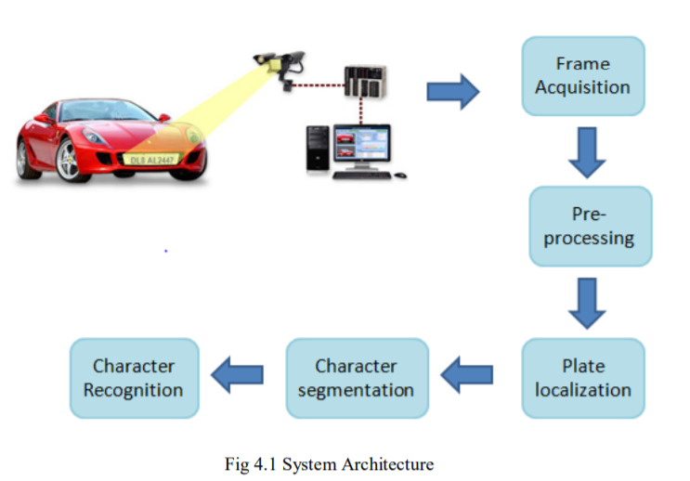

# 3.2 ACTIVITY DIAGRAM

# The main purpose of plate number recognition is the maintenance of vehicle information in relation to its numerical letters. The information can thus be used to track cars.

**First condition:**

* The camera is located at 4 to 5 m from the car so to get a clear view of that vehicle’s number plate.
* Videos are captured and stored in a repository.

**Post status:**

* License plate numbers are visible and displayed at the terminal.

**Standard flow of events:**

* Camera captures video of the car.
* Software identifies and extracts alphabetical number plates for the car was also tested for authenticity.

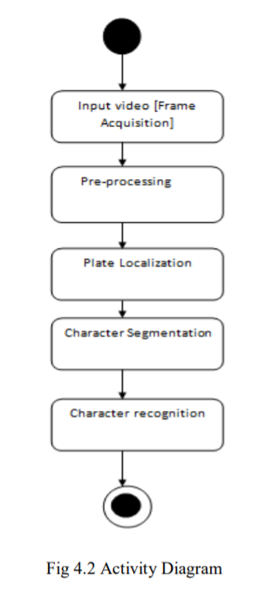

# 

# 3.3 DATAFLOW DIAGRAM

# 

# 3.4: USE CASE DIAGRAM

# 

# Fig 3.4 Usecase Diagram.

**CHAPTER 4**

# IMPLEMENTATION AND RESULTS

**4.1 Platform Selection**

IDLE (“integrated development as well learning environment or short for integrated development area”) is the integrated development platform for Python, with included for automatic language achievement from 1.5.2b1. is Included as part of the Python packaging optional and multi-Linux distribution. It's perfect written in Python and Tool kin GUI tool kit (Tk folding the function).

Integrated development as well learning environment is intended to be a simple and appropriate IDE is the Beginners and especially it is in educational nature. To achieve that, they are separate platforms, and avoid featured clutter.

According to the installed READ ME, it has some main feature as:

Multiple’s windows text-editing software with the syntax-highlighting and auto-complete, smart intendent and others.

Integrated treadmill, persistent rest areas, and stacks visibilities.

IDLE is every time criticized for usability-issues a variety of, it includes the focus loss, lack of copy to paste board feature, lack of the line number options, and general interaction make-up; it is called a "disposable" IDE, because the users often switch to something else for advanced IDE as they receive information.

**4.2 LANGUAGE PLANNING PLAN**

Python is a translated, object-oriented, and highly developed language semantics. Its great built into the information structure, joined with incredible composing also strong ties, making it is more appealing for quicker Performance Enhancement, and to be utilized as a composition or glue dialects to interface the current articles together.

Python is a straightforward, simple to-peruse grammar underline readabilities and consequently diminish the expense of framework support. Python upholds the module and the bundles, which advance the program module utilization and code use. The Python mediator and general library are widely accessible in sources or paired structure liberated from charges on every one of the significant stages and it tends to be unreservedly circulated.

**4.3 CODE CONDUCT STANDARDS**

**1. Vocabulary Meetings**

Module Name- Short, short names and without underusers. Model: myfile.py Category name- Cap Words meeting. Model: My Class Disclosure Terms: - When a module portrays a variation for a wide range of circumstances, it is normal called "Blunder". On the other hand, utilize the Cap Words gathering (for example my mistake.)

Methods and Methods of Variation: - Recommended "Python code style guide." using lowercase letters separated by lowercase letters (example: my variable). Be that as it may, since most codecs utilize a blended Case, suggest utilizing this style (model- Variable)

Utilize just one driving highlight for inner strategies and example varieties (for example secured). Model: _my Var Ported - Use two driving highlights to recognize private classification names Example: __my Private Var - Do not use lead or tracking to emphasize public values ​​without contradictionary1ing reserved names, in which case, one emphasizing trailing is interesting (example: category _)

**2.External import planning**

They ought to consistently be set at top of the records, soon after any module remarks are again report strands, even before the ground module and sturdiness. Importation of merchandise should be isolated lines.

Wrong:- import sys , os

Right:- import sys import os

The followings are OK, in any case: from String import type types, List type

Import should be gathered in after orders in a clear line between each gathering of import:- standard library import - import of enormous related bundle - explicit application import.

**3.Induction and Line-length**

Fix: - 2 spaces (and no any tabs) - Avoid utilizing in excess of 5 degree of content yourself.

Line: - Maximum 72 alphabets or characters (which never surpass 79-characters) - and we can-break a long queues utilizing ‘\’.

**4.Broken lines**

Must leave any-one line in between exercises in class. Another clear line can be utilized to isolate the connected work gatherings. Void lines can be left between a heap of related one-liners. Utilize the clear lines in assignments, gradually, to show legitimate classifications.

**5.White Space**

Such a large number of articulations in similar lines are disappointing.

Wrong: if fun1 == 'blah': key1doblah ();

CORRECT: if fun1 == 'blah': key1doblah ();

There is no void area left preceding the open sections.

Wrong: Spam (1);

CORRECT: spam (1);

INCORRECT: dictionary1 ['key'] = list [index];

CORRECT: dictionary1 ['key'] = list [index];

There are no blank areas inside the sections, sections or sections.

INCORRECT: spam ( ham [1] , {eggy : 2})

CORRECT: spam ( ham [1], {eggy : 2}) ƒ

There is no void area left preceding the comma, colon or semicolon.

WRONG: if param1 == 4:

Then, at that point:- print x, y; x, param2 = y, param1

CORRECT: if param1 == 4:

Then, at that point print x, y; x, param2 = y, param1 17 White Space ( cont.) ƒ

There is close to one space left around the administrator.

INCORRECT: param1 = 1 value = 2 longVariables = 3

CORRECT: param1 = 1 value = 2 longVariables = 3 18 White Space ( cont.) Ƒ

Continuously encompass the accompanying administrator with one spaces on each side - the task (=) - examination (==, =, <>, <=,> =, inside, not inside, inside, not) - Booleans (and, or, no) -

Administrator number juggling (+, -, *,/,%)

Erroneous: in the event that (x == ‘4’) or (x == ‘5’): param1 = param2 + ‘5’

CORRECT: assuming (param1 == ‘4’) or (param1 == ‘5’): param1 = param2 + ‘5’ 19 White Space (proceeded) ƒ

Try not to utilize space around the '=' images when it is utilized to show a catchphrase contention or a document for default boundary esteems.

INCORRECT: def complex (genuine, imags = 0.0 ): and return sorcery ( r = genuine, I = imags )

CORRECT: def complex (genuine, imags = 0.0 ): and reestablish enchantment ( r = genuine, I = imags )

**7.Comments**

Square Comments: Posted at similar level equivalents to the code in which they work. Each line block remarks begins with # with one space. Classes inside block remarks Separated line containing # one. Square remark is better encircled by a clear line above and underneath them, Example: # Compensates borders. This is finished by expanding param1 # by same numbers param1 + = 1 25

Line Quotes: Must beginning with # with one space. It ought to be isolated by somewhere around two posts from the assertions in which they work.

Model: param1 + = 1 # Compensates the line.

**8.Document threads.**

Write threads for all the tasks, community modules, methods and classes. Document cables aren’t required in unpublic ways, but you should be aware about that explains what this method will do. The comment always appears after "define" line. Supplements a clear line prior and then afterward every one of the strands of archive composing a section.

One-line Information Cables: "" "Open and Close" in the same lines - Available there are no blank lines before and after the document thread. It best describes the functions or methods effects as a command ("Do this", "Replace that"), not as the description. Multiple text cables: - "Multi-document document cables must be turned on the line itself. - Script: The script document string should be used as per its application messages. It should record the scripted functions, syntax command lines, and natural variables. - Module: The module document string should list the list as a whole class, variations and functions (and other items) posted by module, with an abbreviation for one line each.

Category: The section document string should be summarized its performance and write to public methods and variations of the model. On the off chance that the class is proposed to be split. and has the extra interfaces of the sub-cuts, this visual interface must be written separately. If the category surpasses another class and its conduct is greatly achieved in that category, its document The string should say this and summarize the difference. The category builder should be written in document string in its __init__ format.

Function or method: The document string should summarize its functionality with the document its arguments, the amount of retrieval, adverse effects, variations expressed, and limitations of when this can to be called. Discretionary contentions are to be shown. Utilize the activities "take out" to show that the subclass strategies supplant the privileged techniques and don't cost an enormous class way use.

**4.4 DESCRIPTION OF MODULES**

The proposed program consists of the following four modules:

**4.4.1 PREPARATION**

Pre-processing steps include the following methods:

**1. Gaussian Blur:** Gaussian Blurring is very effective in removing gaussian noise from picture. Image blurring is achieved by tightening the image with a low-resolution filter.

Removes the most common content (e.g. audio, edges) in a led image the edges are blurred. This way, instead of a box filter containing an equal filter coefficient, Gaussian kernel used. Work done, cv2.GaussianBlur ().

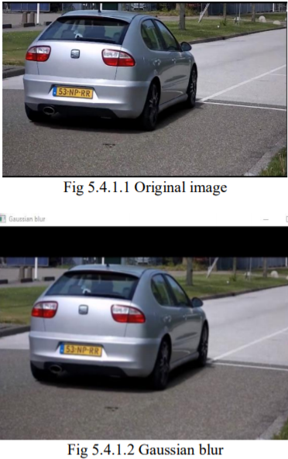

**2. Conversion of gray scale:** Includes conversion of RGB image to image in gray.

An image on gray scale is made of different in color gray. Real color imagery can be converted to a gray scale on keeping the light (light) of the image. Here the RGB image is a combination of BLUE, GREEN and RED, colors. Gray image is found in RGB images by combining this 11% BLUE, 30% RED and 60% GREEN. This provides details for image brightness. Emerging image it will be in pairs. The number “0” represents the color black and number “255” represents the color white.

The range of this remains between color black and color white ‘values’.

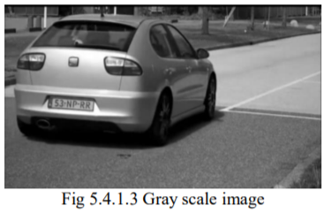

1. **Sobel operator:** Used for image processing and computer vision, in particular within the algorithm of finding the edge where it creates an image that emphasizes the edges. Sobel An edge detector is a method based on the command. Works with the first elements of the order. It counts the first findings of the image by the division of the param1 and param2 axes. Exit only rating (because photos do not proceed)

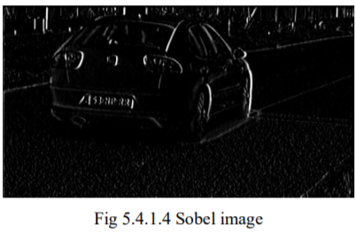

**4. Thresholding:** It Converts a scale of gray images into an image in binary form. If pixel value is greater than limit value, given one value (can be white), otherwise given another value (it can be dark). The function used is cv2.threshold. The controversy over the origin of the image of the source, which should be a gray image.

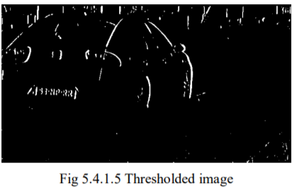

**CHAPTER 5**

# CONCLUSION

**5.1 CONCLUSION**

ALPR applications are becoming increasingly difficult in India's context for good performance developer growth in automotive, two-wheel drive and automotive industries. ALPR requests as default toll collection, automatic charging system in parking lots, management vehicles in the parking lot vacancies, and traffic monitoring, etc., have brought new research activities to ALPR size.

We have automatically upgraded the license plate recognition software by downloading input from live video feed. Character set is used for extraction number plates. Finally, separated letters are identified using an equal square error way.

**5.2 LIMITATIONS**

• Good quality camera is required. The appropriate form of image would not be existing.

• There should adequately lighting.

• This system does not respond well under a variety of lighting conditions.

• Although the accuracy is high, a double error leads to lower computer results.

**5.3 FUTURE DEVELOPMENT**

The proposed systems implementation can be extended to obtain number plates of cars multiple with an image having single frame. Easy-to-use Android applications can design for road rental management systems. Also, character recognition is possible done using a variety of in-depth reading skills as it produces more accuracy. GPUs can be used to achieve multiple operations in terms of calculation.

**Appendix**

**References**

1. Paridhi Swaroop, Neelam Sharma, “An Overview of Various Template Matching Methodologies in Image Processing”, International Journal of Computer Applications (0975 – 8887) Volume 153 – No 10, November 2016

2. Lucky Kodwani & Sukadev Meher “Automatic License Plate Recognition in Real Time Videos using Visual Surveillance Techniques “, ISSN (PRINT): 2320 – 8945, Volume -1, Issue -6, 2013

3. Riazul Islam, Kazi Fatima Sharif and Satyen Biswas, “Automatic Vehicle Number Plate Recognition Using Structured Elements”, IEEE Conference on Systems, Process and Control December 2015, pp 44-48.

4. Muhammad Tahir Qadri, Muhammad Asif “Automatic Number Plate Recognition System for Vehicle Identification using Optical Character Recognition” IEEE 2009.

5. Aniruddh Puranic, Deepak K. T, Umadevi V “Vehicle Number Plate Recognition System: A Literature Review and Implementation using Template Matching” International Journal of Computer Applications (0975 – 8887) Volume 134 – No.1, January 2016

6. Byung-Gil Han, Jong Taek Lee, Kil-Taek Lim, and Yunsu Chung “Real-Time License Plate Detection in High Resolution Videos Using Fastest Available Cascade Classifier and Core Patterns” ETRI Journal, Volume 37, Number 2, April 2015

7. Nighat Naaz Ansari, Ajay Kumar Singh “License Number Plate Recognition using Template Matching” International Journal of Computer Trends and Technology (IJCTT) – Volume 35 Number 4- May 2016

8. M. M. Shidore, S. P. Narote,” Number Plate Recognition for Indian Vehicles” IJCSNS International Journal of Computer Science and Network Security, VOL.11 No.2, Feb. 2011

9.M. Dorigo, V. Maniezzo and A. Colorni, "Ant system: optimization by a colony of cooperating agents," in IEEE Transactions on Systems, Man, and Cybernetics, Part B (Cybernetics), vol. 26, no. 1, pp. 29-41, Feb. 1996, doi: 10.1109/3477.484436.

10.JJ. van Ast, R. Babuska and B. De Schutter, "Fuzzy Ant Colony Optimization for optimal control," 2009 American Control Conference, 2009, pp. 1003-1008, doi: 10.1109/ACC.2009.5160327.

11.I.Michelakos, N. Mallios, E. Papageorgiou and M. Vassilakopoulos, "Ant Colony Optimization and Data Mining: Techniques and Trends," 2010 International Conference on P2P, Parallel, Grid, Cloud and Internet Computing, 2010, pp. 284-289, doi: 10.1109/3PGCIC.2010.47.

12.R. Ramachandran, R. Nidhin and P. P. Shogil, "Anomaly Detection in Role Administered Relational Databases — A Novel Method," 2018 International Conference on Advances in Computing, Communications and Informatics (ICACCI), 2018, pp. 1017-1021, doi: 10.1109/ICACCI.2018.8554752.

13.A. Sasi, S. Sharma and A. N. Cheeran, "Automatic car number plate recognition," 2017 International Conference on Innovations in Information, Embedded and Communication Systems (ICIIECS), 2017, pp. 1-6, doi: 10.1109/ICIIECS.2017.8275893.